AWS EC2 PROJECT
Launching an Amazon EC2 Instance

1. INTRODUCTION
Amazon EC2 (Elastic Compute Cloud) is an AWS service used to create virtual servers in the cloud. This practical demonstrates the process of launching an EC2 instance using the AWS Management Console. The provided screenshots show the actual sequence from the EC2 dashboard through instance configuration, launch, instance verification, connection, and the Amazon Linux terminal.

2. PROJECT OBJECTIVE
The objective of this practical is to launch and verify an Amazon EC2 virtual machine using the AWS Console.
- Open the Amazon EC2 service.
- Start the Launch Instance process.
- Select Amazon Linux 2023 as the AMI.
- Select the t3.micro instance type.
- Configure a key pair and network settings.
- Configure storage and review the instance summary.
- Launch the EC2 instance.
- Verify that the instance is running.
- Open the Connect to instance page.
- Connect to the Linux instance and reach the Amazon Linux terminal.

3. CONFIGURATION SHOWN IN THE PROVIDED FILE
Configuration | Value shown in screenshots
AWS Region | Europe (Stockholm)
Instance name | sakshi
AMI | Amazon Linux 2023
Instance type | t3.micro
Storage | 1 volume – 8 GiB, gp3
Firewall | New security group
Public IPv4 | Enabled

Step 1 — Open the EC2 Dashboard
The first screenshot shows the Amazon EC2 Dashboard in the Europe (Stockholm) region. The dashboard contains the Launch instance option and EC2 resource information.

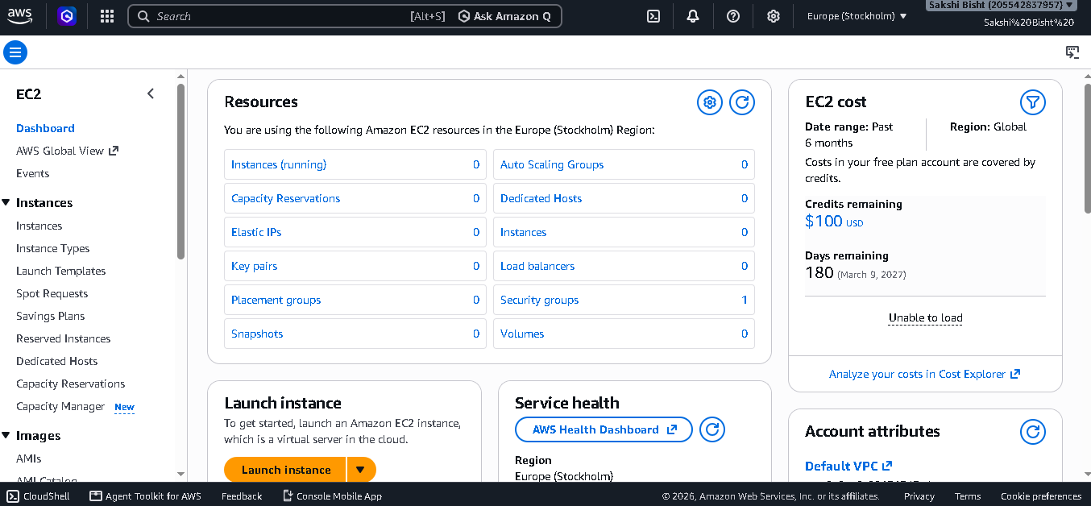

Step 2 — Start Launch Instance
Select Launch instance. The Launch an instance page opens. The instance name shown in the file is “sakshi”.

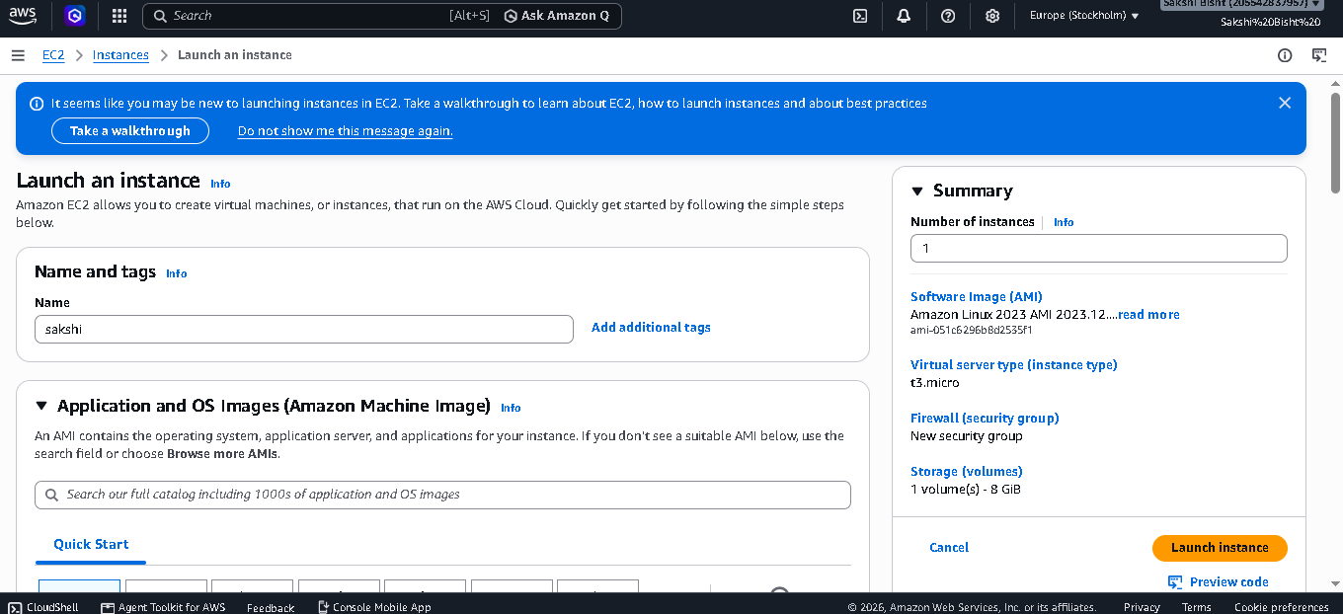

Step 3 — Select the AMI
Under Application and OS Images (Amazon Machine Image), Amazon Linux is selected. The screenshot shows Amazon Linux 2023 as the selected machine image.

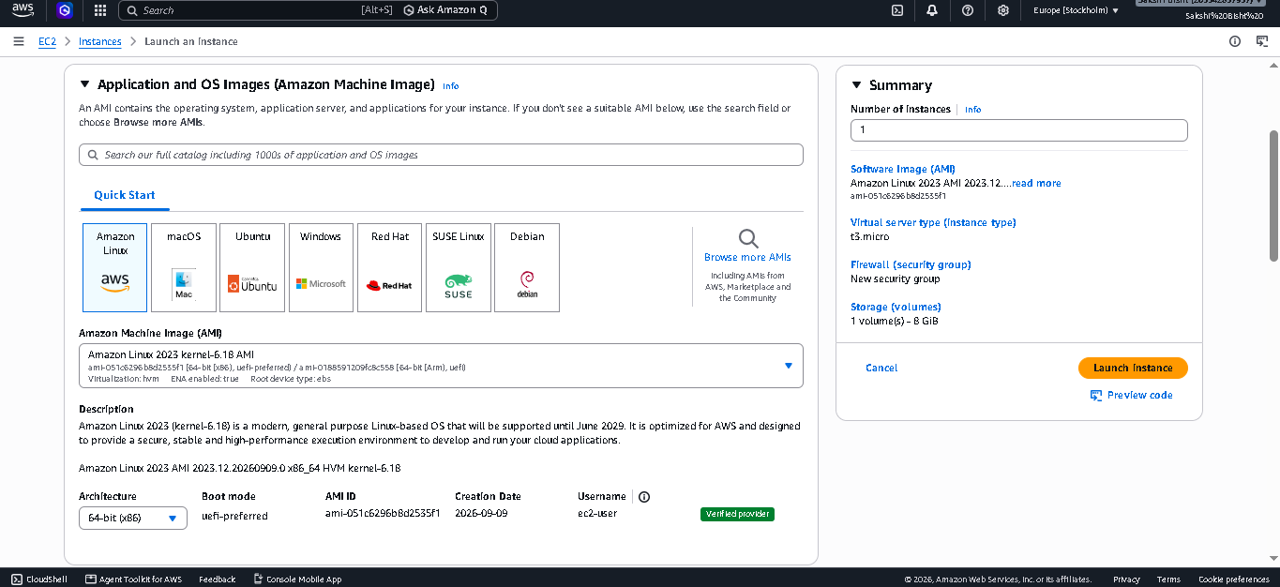

Step 4 — Select the Instance Type
The instance type shown in the provided file is t3.micro. The screen marks it as Free tier eligible in the shown account configuration.

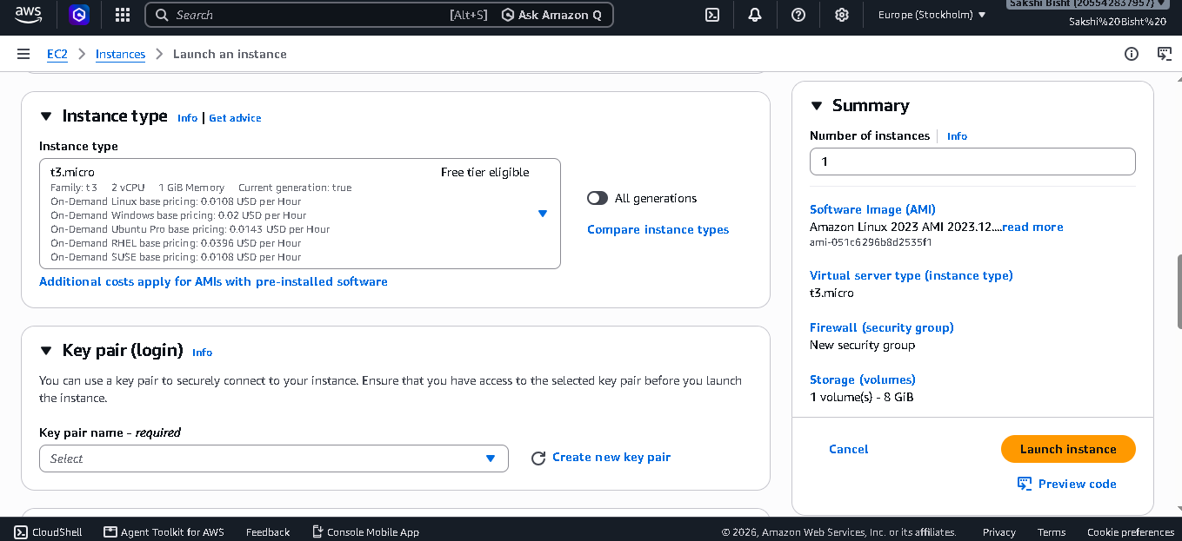

Step 5 — Configure the Key Pair
The Key pair (login) section is displayed. The screenshot shows the key-pair selection area and the Create new key pair option.

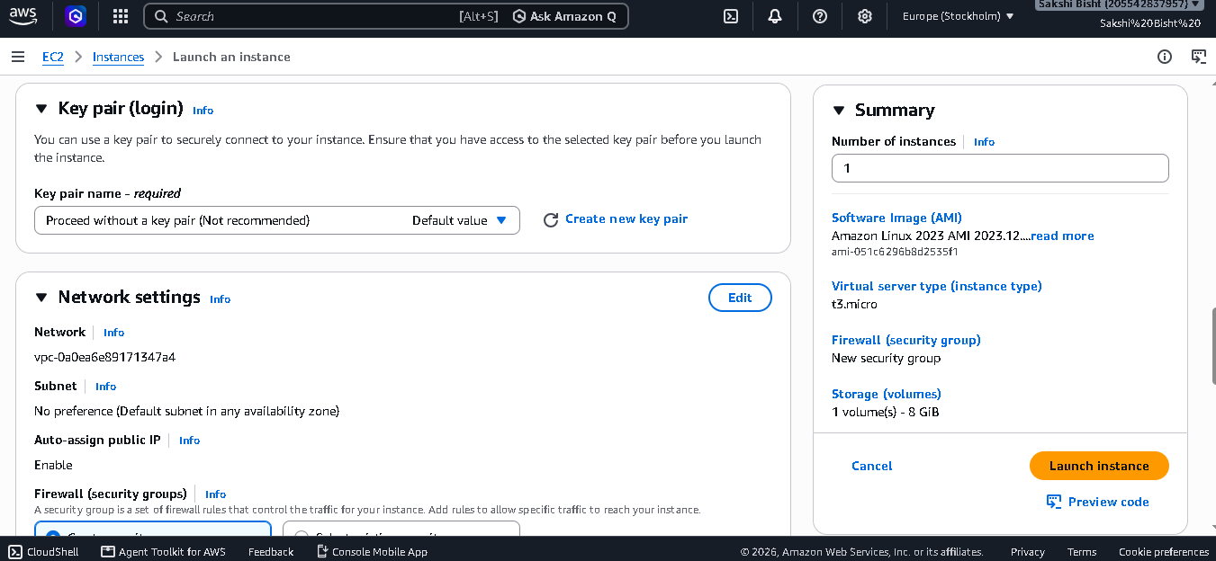

Step 6 — Configure Network Settings
The Network settings section shows the selected VPC/subnet area and Auto-assign public IP set to Enable. A new security group is selected.

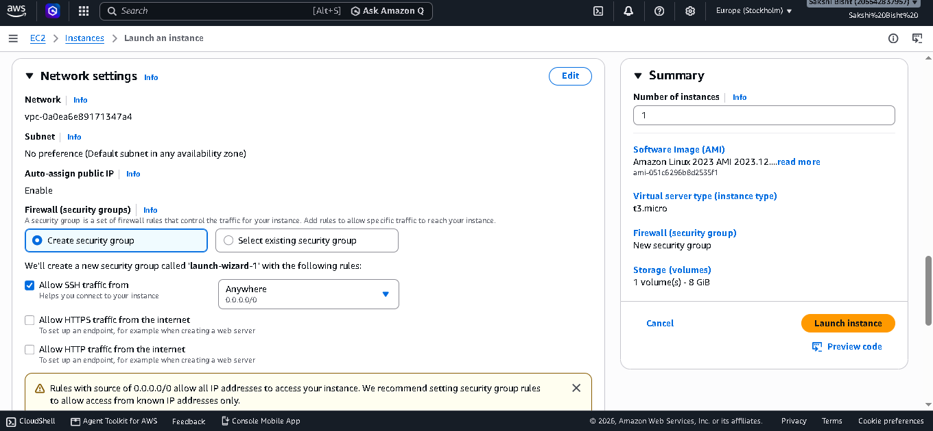
Step 7 — Configure Firewall Rules
The screenshot shows the firewall rules section for the new security group. The shown configuration includes SSH access and options for HTTP/HTTPS traffic.

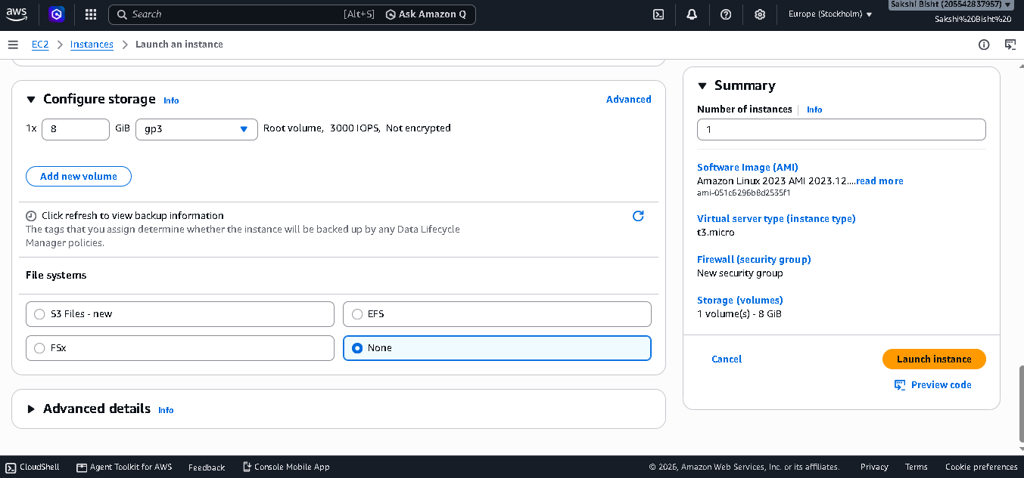
Figure 7: Firewall / Security Group configuration
Step 8 — Review the Instance Summary
The Summary panel shows one instance, Amazon Linux 2023, t3.micro, a new security group, and one 8 GiB
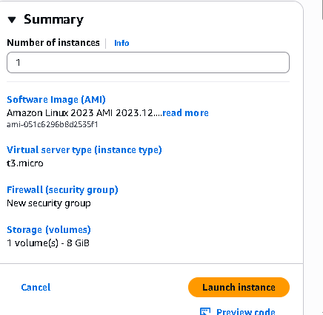
storage volume.

Step 9 — Review Storage
The Configure storage section shows one 8 GiB gp3 root volume. The file also shows the file-system options and the Advanced details section.

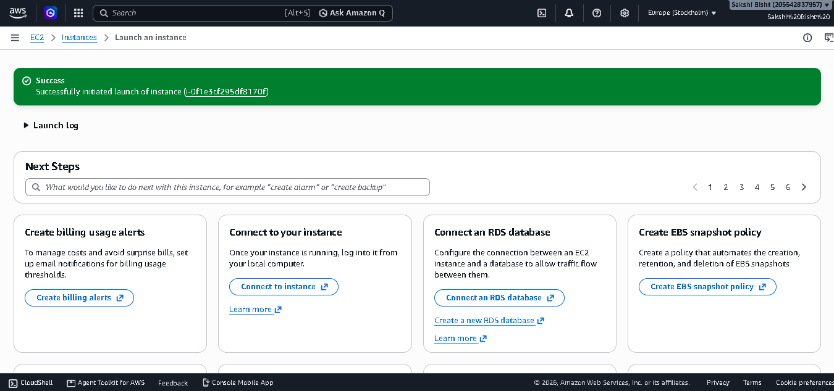

Step 10 — Launch the Instance
After reviewing the configuration, click Launch instance. The next screenshot shows a green Success message confirming that the instance was successfully launched.

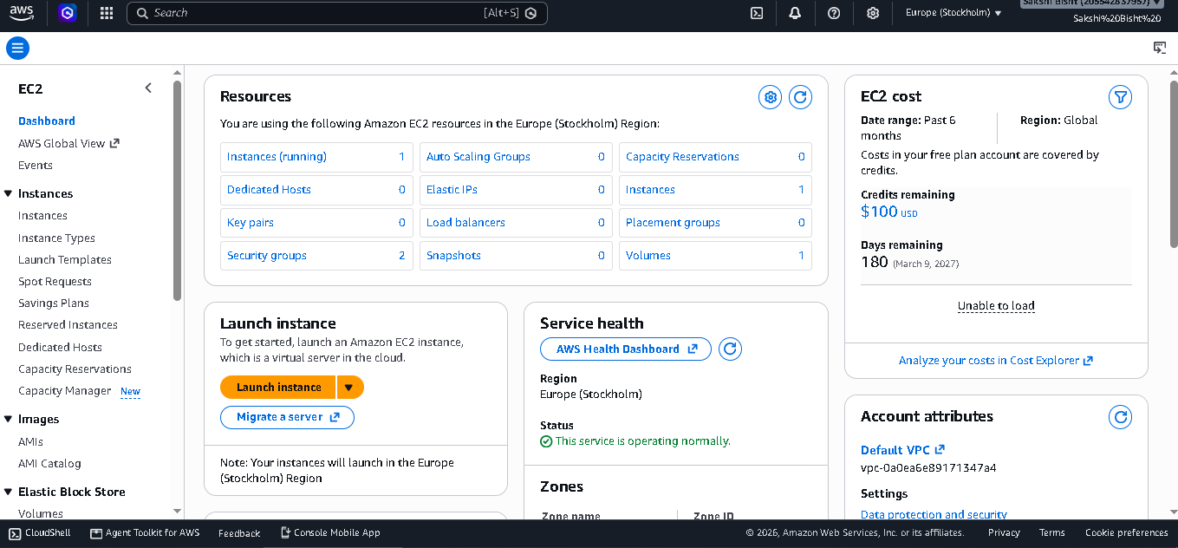
Step 11 — Verify the EC2 Instance
The EC2 Instances page shows the instance named “sakshi” with a Running state. The screenshot also shows status checks and a public IPv4 address column.

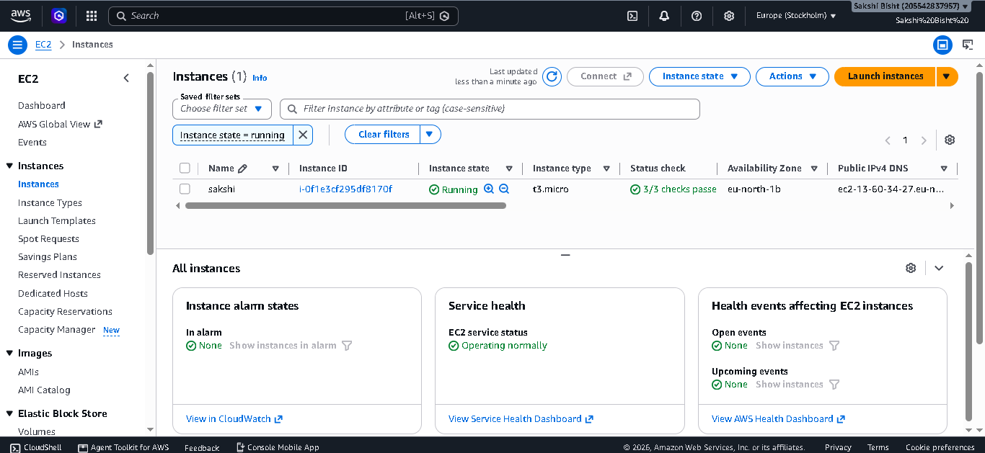

Step 12 — Connect to the Linux Instance
Select the running instance and choose Connect. The Connect to Linux instance page is displayed. The screenshot shows EC2 Instance Connect / in-browser connection as an available method.
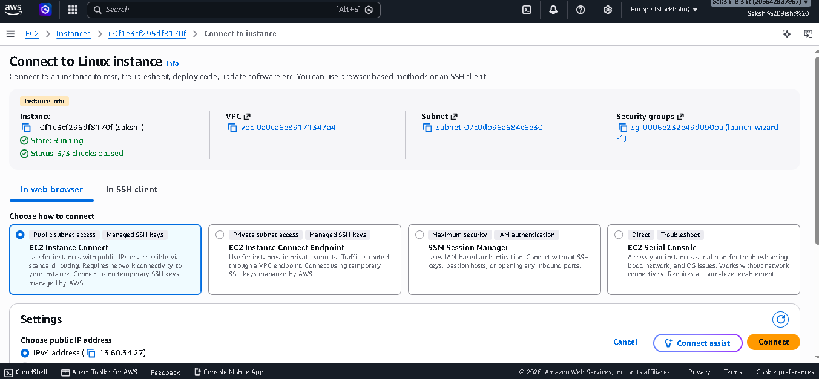
Step 13 — Reach the Amazon Linux Terminal
The final screenshot shows an Amazon Linux 2023 terminal session. This confirms that the Linux instance has been reached successfully.
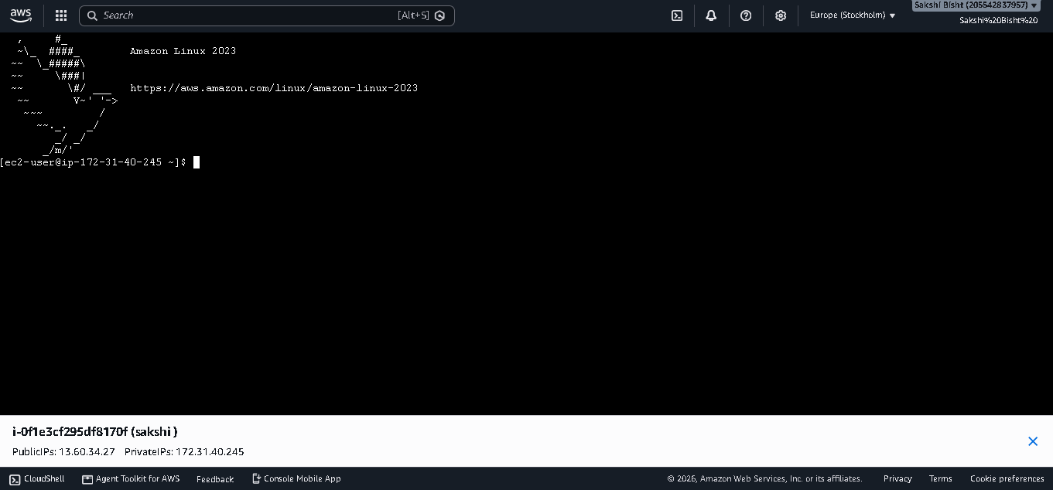

4. FINAL RESULT
According to the provided screenshots, the EC2 instance was successfully launched in the Europe (Stockholm) region. The instance uses Amazon Linux 2023 and the t3.micro instance type, with an 8 GiB gp3 volume. The instance reaches the Running state, the Connect to Linux instance screen is available, and the final screenshot shows an Amazon Linux 2023 terminal session.

5. CONCLUSION
This practical demonstrates the complete basic workflow for launching an Amazon EC2 instance through the AWS Management Console. It covers AMI selection, instance type selection, key-pair configuration, networking, storage, launching the instance, verifying its running state, and connecting to the Linux server.
It is an AWS-provided way to connect to a supported EC2 instance from the AWS console/browser.

